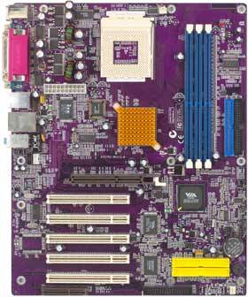

Suspend to RAM (STR)  
USB 2.0  
PROMISE IDE RAID Controller (optional)  
IEEE 1394 (optional)  
Supports DDR333  
Supports UltraDMA 133/100/66  
  
Processor  
AMD® Athlon XP / Athlon / Duron CPU  
Socket A  
RAID IDE array controller  
  
Chipset  
VIA® Apollo KT333 North Bridge VT8367  
VIA® VT8235 South Bridge  
  
Super I/O  
ITE IT8705F  
  
Main Memory  
3 DDR DIMMs  
Supports DDR333  
Max. 3GB  
  
  
Sound  
VIA VT1612A AC'97 Audio CODEC  
2 Channel  
  
LAN  
RealTek RTL8100B 10/100Mbps PCI LAN Chip (optional)  
VIA VT6103 Fast Ethernet 10/100 PHY / Transceiver (optional)  
  
IDE  
2 UltraDMA 133 / 100 / 66  
  
USB  
6 USB 2.0 (Embedded in VT8235)  
  
IEEE 1394 (optional)  
VIA VT6306 integrated IEEE 1394A Host Controller (optional)  
  
Expansion Slots  
5 PCI  
1 AGP (4X)  
1 CNR  
  
Back Panel I/O Ports  
1 PS/2 Mouse  
1 PS/2 Keyboard  
1 Parallel  
2 Serial  
1 IEEE 1394A (optional)  
1 Game Port  
2 USB  
1 LAN (optional)  
1 Line-in  
1 Line-out  
Microphone  
  
Internal I/O Connectors  
IrDA header  
CD-in header  
2 extra USB ports  
1 IEEE 1394A header (optional)  
CPU and Case fan connectors  
Single color LED header  
20-pin ATX power connector  
4-pin ATX power connector  
  
BIOS  
AMI 2Mb Flash EEPROM  
  
Form Factor  
ATX  
  
Board Size  
305 mm x 244 mm

CPU

* Fabricante:  AMD
* Familia:  AMD ATHLON XP
* Modelo: 1700+
* p/n: AX1700DMT3C
* Frequencia:  1700 MHz (rated) , 1467 MHz (real)
* Velocidad Magistral:  266 MHz
* Socket: SOCKET 462
* l2 cache: 256 KB
* Multiplicador: 11

Bibliografia

<http://www.motherboard.cz/mb/ecs/k7vta3v50.htm>

<https://www.arreglatelo.es/es/cpus-procesadores/16333-procesador-amd-athlon-xp-ax1700dmt3c-agoia-0209vpiw-y7840970106.html>